**Quirky case description**

*“We make invention accessible. We believe the best ideas in the world aren't actually in the world... they're locked inside people's heads. We exist to solve that problem.”*

# Intro

*For centuries, becoming an “inventor” has been a hard gig to crack. Complexities relating to financing, engineering, distribution, and legalities have stood in the way of brilliant people executing on their great ideas.*

*Since launching in 2009, Quirky has rapidly changed the way the world thinks about product development. We bring at least three brand new consumer products to market each week, by enabling a fluid conversation between a global community and Quirky's expert product design staff. The world influences our business in real-time, and we share our revenue directly with the people who helped us make successful decisions.”*

*With the help of a growing online community, Quirky comes up with two new consumer products a week. It works like this: a user submits an idea and if enough people like it (as on Facebook), Quirky's product-development team makes a prototype. Users review this online and can contribute towards its final design, packaging and marketing, and help set a price for it. Quirky then looks for suitable manufacturers. The product is sold on the Quirky website and, if demand grows, by retail chains. Quirky also handles patents and standards approvals and gives a 30% share of the revenue from direct sales to the inventors and others who have helped.*

# Rules of Quirky in general

Joining the Quirky community is free. Quirky’s mission is to “Make invention accessible”. Their “job is to act as sort of shepherds of our inventions”. For Quirky to go forward with an idea the community has to like it and the idea also has to solve a problem. Once accepted, the product license and copyright become property of Quirky, as explained in massively long terms and conditions. Quirky does not patent its ideas: “Nothing. Speed to market is our best protection”, but patents may be used as inspiration for ideas, especially from their partner GE. The company runs a regular weekly schedule (This invention machine stops for no one, so our live product brainstorm will still be held at its regular hour (6 pm)”) with product development related events, and follows quite consistent development process. Although the company emphasizes collaboration with users, the vast majority of work appears to take place behind the scenes, by the paid employees (professional designers and engineers). Most of the tasks users are asked to do are rather simple and quick. Their timeframes vary: idea evaluation is open for 30 days for each idea, while research, naming or design tasks might be open just for 2-7 days, or even less. Time left for completing the tasks is shown with counters. Task may have limitations in amount of contributions per user, for example 15 votes per day for idea evaluation, 3 votes for design project, or 1 submission to design project.

In general the participants of Quirky are expected to:

1. Stay active
2. Participate in everything: Influence from both the smallest actions and largest contributions
3. Converse in the forum: Remember to be civil and open minded!
4. Message other members: We encourage communicating with members about their ideas etc. but avoid filling inboxes with promotion for your idea. (User needs to follow you before you can send him a message)
5. Follow and be followed
6. Give props where props are due: When community members do a good work, give ‘em a pat on the back
7. Specify your skills: Now’s not the time to be humble, show off your skills!
8. Use your real name: We offer alias function, but we prefer real names
9. Think outside the box: Quirky sales = money in your pocket
10. The more you hype up Quirky and get people to click, the more influence / cash you’ll earn
11. Promoting this link will earn you credit for actions taken by visitors: Up to 10 % for sales, 20 % commission on paid idea submissions
12. Find your social sales link: Social sales give you opportunity to stimulate final phase by cold, hard sales
13. Engage with the community: Check back often to see how people are commenting
14. Learn from the best
15. Do your research

Quirky’s speciality is measuring of influence to divide the rewards to participant. Influence is a real-time measure of user’s contribution to a project and measures the percentage of community’s total share in a product. Influence generates money: 70 % of Quirky sales goes to the company while the rest 30 % (10 % for indirect sales) is divided among community members who influenced the product, based on influence percentage. The inventor (ideator) takes the lion’s share, while smaller tasks earn less. There’s no hard-and-fast rule or guarantee for earning influence: it is awarded on sole discretion of Quirky and depends on many factors.

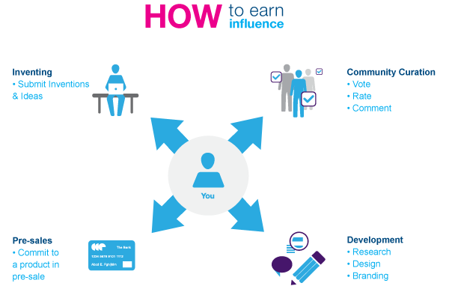

*Influence is a real-time measure of your contributions to a project. There are many ways to get involved with Quirky, whether you’re submitting a winning invention, voting on member ideas, or pitching in on a design project. If any of these contributions impact a finished product, you’ll earn yourself a share of the profit, and influence is the way Quirky measures that share. Influence comes in the form of a percentage: specifically, a percentage of the community’s total share in a product. See, once a product is manufactured and sold, the Quirky community receives 30% of the total revenue generated by direct sales on Quirky.com, and 10% of the revenue from indirect sales (wholesale orders and worldwide retail sales). This community pot is divided among all the community members who influenced the product, based on each member’s influence percentage. Still confused? No worries, there’s more to it. So how does it all work?*

*Think of the Quirky influence engine as a complicated, evolving recipe, made up of many different ingredients. Each phase of the development process represents a single ingredient, and a portion of the total influence for that product. No two products are alike, so the number and type of phases that are needed for each product may vary, but the total influence will always add up to 100%.*

Percentages for typical tasks are still listed on the website are presented in the following table.

|  |  |  |
| --- | --- | --- |
| **Task** | **Description** | **Influence %** |
| Idea submission | If your idea takes off and is picked for development, you'll receive the largest percentage of the community pot when your Quirky product starts flying off shelves! | 42 % |
| Collaboration | Submit a revision using Quirky's collaboration tool: if the ideator accepts your revision, you could earn yourself a portion of the collaboration influence. If no major revisions are submitted and accepted, this percentage is added to the Sales influence total, described below. | 6 % |
| Comparison | Product development is competitive, so Quirky encourages users to browse the web for products that are similar to submissions, and to submit them as a Product Comparison. Each submission can have a total of five, and the 3% influence is split between the 5 contributors | 3 % |
| Winning votes | Have you stumbled upon an idea submission that you want in your hands, RIGHT NOW? Vote for it! If the idea you voted for is selected, you’ll have earned yourself a piece of the revenue pie. The 6% influence is divided amongst all voters for a winning idea. | 6 % |
| Losing vote | The idea you voted on was placed Under Consideration, but didn’t make it past staff evaluation. That’s okay, we still want to give you credit for pitching in: while the idea you voted for didn't make it, we'll award you influence in every other product that won that week. 3% of each product's influence goes towards this reward. | 3 % |
| Research | Quirky conducts market research in the form of surveys: help us out with some answers, and you’ll earn a cool percentage of the product’s retail revenue. We split the project’s 5% influence between everyone that participates! | 5 % |
| Design | Our design team wouldn’t be able to launch two ideas a week without your help. If you submit an idea for a new feature or improvement that they use in a final design, you'll receive up to 3.75% of that product's influence. Voting for a selected idea earns you influence as well. Winning ideators split 3.75% of the project’s influence, while winning voters split a total of 1.25% influence. | 5 % |
| Refine | There’s always room for improvement, don’t you think? We’ll open up this phase when we need your help smoothing out the kinks in the design process. 5% of the product's influence will be split between those who participated. | 5 % |
| CMF | Color. Material. Finish. Our design team provides the choices, and you pick them! The project’s 5% influence is divided among the members who voted for the winning option. | 5 % |
| Naming | Members can submit and vote on potential product names, and the most popular will be made official! The winning name will receive 3.75% of the influence, while winning voters will split the remaining 1.25%.  Note! This has changed after the introduction of the Naming Game! | 5 % |
| Tagline | A product's name may give it an identity, but the tagline gives it character. Much like the Naming phase, this project allows members to submit and vote on ideas for product taglines. 3.75% infuence goes to the winning submission, while 1.25% goes to the folks who voted for it.  Note! This has changed after the introduction of the Naming Game! | 5 % |
| Pricing | When a new product is launched on the Upcoming Page, a seven day countdown is started. Share your input on the product's price before the timer runs out, and you'll be awarded a portion of influence! The total 10% influence is split between those who shared data within the first 7 days. | 10 % |
| Sales/ SKU Selecting | When we launch a product, anyone who contributed to its development will have the chance to earn more influence by being one of the first to buy. Simply purchase the product from the Quirky store within its first two weeks, and you'll add another chunk to your total influence. The amount of influence split between buyers can vary from 15-25%, depending on the number of other phases included in the product's development. The number can go up if we skip a refine phase, down if we add a second design phase, etc. | 15-25 % |

*Keep in mind that there’s no hard-and-fast rule or guarantee for earning influence.*

*Influence is awarded at the sole discretion of Quirky’s platform and team. A user’s influence earnings in a given project depends on many factors: the number of phases in the project, the number of people who contributed to those phases, the number of ideas submitted by the people who contributed to those phases… you get the picture. We are constantly working to improve and evolve our influence engine. Back to the cooking metaphor: the ingredients may stay the same, but the recipe itself will vary.*

If Quirky makes a product an user has influenced, the user earns royalties for as long as Quirky is selling the product. Quirky makes money only if user’s ideas are successful and users make money only if Quirky can make profit

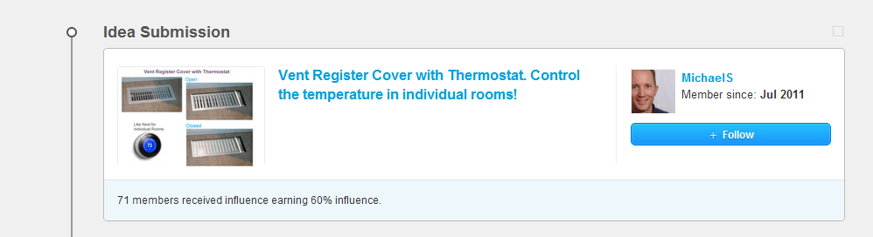

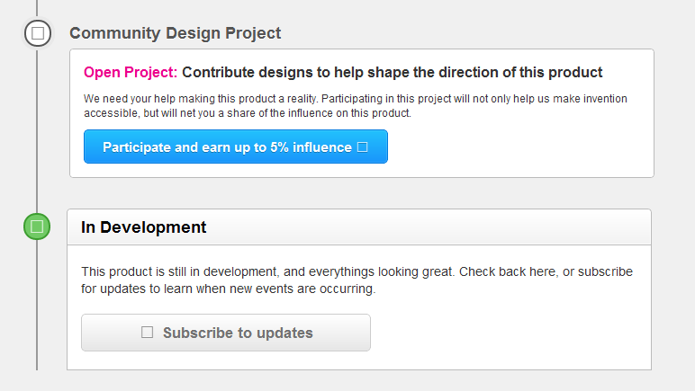

# Tasks of Quirky in general

The Quirky website offers many simple and easy tasks for participants. There appears to be new things to do every day. The tasks are mostly well-defined and easy, with varying timeframes for completion. Typical projects a participant can influence include:

* Help choose our next product
* Help research our laundry alert product
* Help design our collapsible bike helmet
* Help research…

Still user may at times run out of things to do. Apart from always present idea evaluation and voting, the number of tasks available is limited. It appears Quirky would not need the community to do most of the tasks, but the company has chosen to share these parts of product development with the community. Vast majority of the work takes place behind the scenes: projects are judged by Quirky staff, most of the prototyping and concept refinement are done by in-house designers and engineers.

In addition to specific tasks to complete, Quirky also gives instructions for the community on more general tasks, or rather behaviors that are preferred:

1. Make Sure Your Idea is Feasible
2. Focus on Viability, Marketability, and Innovation
3. Perfect the Art of the 140-Character Pitch
4. Clearly Describe the Problem and Solution or Product and Customer
5. Learn From the Best
6. Do Your Research
7. Attach, Attach, Attach
8. Engage with the Community
9. Find Your Social Sales Link
10. Use Twitter, Facebook, Pinterest, Etc.
11. Pick a Product
12. Think Outside the Box
13. Use Your Real Name
14. Specify Your Skills
15. Give Props Where Props Are Due
16. Follow and be Followed
17. Message Other Members
18. Converse in the Forum
19. Participate In Everything
20. Stay Active
21. Cast Your Votes Wisely
22. Sort And Sift
23. Play the Pricing Game
24. Participate in Research

Quirky does not contain much content related to learning. Learning related material is mostly links to Quirky timelines or content, not so much learning resources. For example:

* Check back here, or subscribe for updates to learn when new events are occurring
* Please refer to the timeline to learn more about the development of this product
* Check out the video clip and mind-map from the session (brainstorm)
* Learn more <link>

*You can jump in, help develop products, and accumulate influence in your own Quirky account. Here’s a breakdown of how to do that.*

***1. Submit a product idea.***

*If Quirky chooses it for development, you will be awarded a large chunk of influence, generally 35% or more. We’re focused on consumer products that would retail for $150 or less and do not require any integrated software or programming. Wondering how to make the most of your submissions? Visit our Learn section and click on the Best Practices tab for tips.*

***2. Vote for ideas you love.***

*Voting in Eval: If Quirky marks an idea you voted for as “under consideration,” you will be awarded influence. You have unlimited votes, but be aware that you will gain less influence if you voted for a huge number of submissions in the past 7 days. Treat voting like you’re shopping on a budget instead of going on a shopping spree. Would you really buy the product described?*

*Voting in a development project: If Quirky chooses a concept, design, name, tagline, etc. that you voted for, you will gain influence. You are helping us decide the best way to design that product!*

***3. Rate product ideas that are “under consideration”.***

*If you rate all four criteria (uniqueness, usefulness, wow factor, likeliness to purchase) for 75% or more of the ideas in a round, you will earn influence for that round. On our scale, 1 star = least and 5 stars = most.*

***4. Participate in surveys.***

*If you answer 75% or more of the questions in a research survey, you will earn influence for that product. Occasionally, the design team will post ethnographic surveys, where they ask you to post a picture or video of something. If you follow instructions, you will earn influence.*

***5. Submit designs, names, and taglines in development projects.***

*If Quirky chooses your idea as a winner, you will be awarded with influence for that product. Each product is different, so pay attention to instructions at the top of each project. That’ll give you a better chance of success.*

***6. Commit to products in presales.***

*We will email you to come back and complete your order when we’re ready to ship that product. If you complete your order before the presale cutoff (generally 2 weeks after we’ve emailed, we would include that info in the email), you will earn influence for every presale unit that you purchase.*

# Agents and user experience

The Quirky website has friendly style, which is somehow similar to that of OpenIDEO. On the first browsing the design appears to be very nice and the company blog seems lively. Going through all the posts will be impossible. I find myself being enthusiastic about the site. This might be a great site to participate to learn about product design. Learning part of the site feels simple and clearly organized. I quickly feel like understanding the whole approach of Quirky. On the first impression the site feels instantly ingenious. Tasks are well defined, fun and easy, and a new user can quickly participate meaningfully. Possible caveat: already in the beginning I was somewhat familiar with Quirky: I know they do collaborative product development, where users post and evaluate ideas and Quirky team builds prototypes and takes care of manufacturing.

It is user’s responsibility to find out what to do next. When checking available tasks on the site it seems like there’s new things to do every day, in addition to ever-present idea evaluation. Time frames for tasks vary. It can be difficult to know which tasks have already been completed; the user can only rely on his memory on this. The site appears to have very quick turn-around: there are new tasks almost every time a user logs in again. There are usually many simple and easy tasks available, and somehow there’s an expectation they all will pay off in real money, at least a little bit. It is possible to do just a few tasks very quickly. Sometimes the user may run out of tasks, expect for evaluating or submitting ideas.

Quirky aligns selfish motives of users neatly with its own business goals: the approach is just genius on the first impression. Influence is only earned if user works on something that becomes a product, which gives an incentive for self-selection. I managed to gain some influence already on the very first visits to the site (0.4 % for voting and 0.006 % for participating in a survey), which felt nice. On the other hand some users at the discussion forum complain that paid Quirky team members should not expect free input from the community, as they do not want to be ripped of influence.

Checking the upcoming prouducts section reveals Quirky is making way many products! Just wow! At the time there were 240 ideas in development, although most of them did not have any tasks open for the community. Is the vast majority of the work taking place behind the scenes?

Perhaps some of the strongest feelings on the site are generated by different forms of feedback. Getting influence is exhilarating in the beginning (Sandpaper sticks, 0.00601 % influence). This might be similar to for example unexpected likes on social media, causing unexpected dopamine (?) surges. Also here I developed a bit of a habit of checking whether anyone had commented my design contributions (sensor cube and Piggy app). It is easy to understand why people get enthusiastic when their products are selected for development or produced.

# Feedback

|  |  |  |  |
| --- | --- | --- | --- |
| **Category** | | **Description** | **Examples** |
| Quirky | Statistics | Statistics on user’s activities, both personal and at community level | This Week's Top Earners - email  1 Jake Zien  Earned:$26,160.45  2 Lemonheads  Earned:$6,198.09…”  ”68 members received influence earning 60 % influence” |
| Automatic feedback | Feedback the site generates automatically in response to user’s actions. | You’ve completed enough of this survey to earn full influence! |
| Disappearance as feedback | Making things go away can feel satisfying. | While checking what pod power is, I did the pricing task. Kinda just to make it go away.  Disappearing items in the Naming Game. |
| Staff feedback | Feedback directly from the Quirky staff. Usually as comments to ideas, blog post or messages on the discussion forum, or little notes in product timelines. | This is Steve’s first invention with Quirky. Anna and I enjoyed Skyping with him. Nice to get to see our international inventors in real time |
| Comments from other users | Good luck | A user wishing luck for another community member of his/her idea. | Good luck! |
| Congratulations | A user or Quirky staff congratulating a community member for getting an idea to the next stage. | Congrats on UC! |
| I like this | A user expressing liking an idea. | I really like this idea, for some reason the robot from “Lost in Space” comes to mind… |
| Positive | Simple positive comments on an idea. May contain reasoning for why the idea is good, but often only state the functionality of the idea, if even that. | Clever.  Good!  This is a great idea.  It takes customizing footwear and accessories to another level. Cool concept… |
| Negative | Negative comments on an idea. Often involves some level of reasoning for example why the idea is not going to work. | I think this is limited because it doesn’t allow for adjustable water/rice ratio  Please don’t assist him in this - it is 100 % someone else’s idea |
| Agree | Stating an agreement with other user, usually in comments section of ideas. | Agreed.  Agree with DQ… love the built in flour concept!  You are absolutely right! I love rice too… |
| Colors (?) | Comments on color preferences, especially in comments to CMF project. Perhaps not a separate category after all. | Nicest colors.  Definitely the best combo.  Red looks good for the button, but from a safety standpoint red could also be used for the casing around the cutting blade. Voted |
| Problems / requirements | Attempts to define problems or requirements in response to an idea. | I figure this is the most likely to get packed up & brought to grocery store… However, excessive torque… ensure the product is light enough  Yes, I agree some germs are necessary for our immune system. However, Raul, I was thinking more in terms of “Who the heck wants to clean mold off tub?”  I am a little worried about the muffin toppers. Doesn’t moisture have to escape while it is cooking? |
| Already done | Pointing out the idea has already been implemented elsewhere. | I laughed so much when I saw the image. But then I searched for it and found it on 589 blogs declaring it the best idea. |
| Suggestions | Suggestions for improvements | Designers need to mix this with ratcheting for perfect grapnel!  Wonderful… I’d love to see staff links on track and have the bumps arise out of the music notation. That would teach kids how to read music  Fun. I added a suggestion |
| About users | Assessments on what the users’ opinion on an idea or product would be. May refer to people in general, known users (friends and relatives) or oneself as a user. Indication to buy may be included. | What a wonderful invention! Would be essential to so many people of all ages.  This would help my sister if this was on the market to buy!  Being a whole leaf tea drinker, this is a great way to make sure you get 2-3 infusions from leaves. Great idea! I’d buy! |
| Would use | Stating an indication to use the product, if it was available. | I would definitely use this in my projects as I hate using a tape measure or ruler |
| Voted | Stating that the user has voted an idea. Perhaps the most common comment on ideas. | Voted!  Great, voted! |
| Please check my idea | Requests to check the idea of the commentator. Often combined with voting. Sometimes obvious spam (the same message from the same user to many ideas.) | Voted! Please check my idea.  Hello great idea! Good luck with it! Believe in it. Also consider my ideas. Thank you very much. Voted |
| Thanks | Thanking other users. Usually in response to a vote or a comment. | Thank you <name>!  Thanks for your support |

Quirky features many forms and flavors of feedback to users. All ideas receive feedback from community in the form of votes and comments, and ideas that are put Under Consideration receive also feedback directly from Quirky staff. In ideal situation every idea would get good feedback and that is something at least some of the staff members would like to fix. Still, the feedback from staff is not the point of the Quirky process, and ideally there would be no need for it at all. Automatically generated feedback reports are mentioned a few times here and there, but I have never seen one. Most ideas never make it out of community curation. As an example someone pushed strongly his idea on Edible Frisbee, but “Fortunately we had 12000 community members tell the inventor his idea was the stupidest thing they ever heard”.

The ideas in evaluation can be sorted by the most active, and this can create a feedback loop of votes. A few users even complain about this on the discussion forum: “Once you get on the most active roller coaster you keep riding.” “The most active section must be fixed. Same 10 ideas stuck on top.” I was also susceptible to this feedback loop on a couple of occasions. I voted an idea because it said it had 92 % new votes and the idea seemed to be generating a lot of activity. Another time I voted an idea just because it had 400+ votes according to the title and I just wanted to be part of it if the idea happens to go through. So many people cannot be wrong… In the naming game the system shows the current ranks of evaluated names after the click. Unlike the Most Active category on ideas, this feedback does not give away all the results as the user cannot see the ranks of all the names. The Pricing game shows statistics on current projected price and comparison of aggregated and user’s choices in a bar chart, which creates a feeling of getting the price right or wrong depending on the results, and can lead to adjustments in pricing tasks.

It is possible to see how each product is selling in real time. Ideator gets his photo on the package and influencers have their names mentioned on it. In one case this meant 300 names.

Sometimes the Quirky staff provides feedback to the community through streamed shows, such as Feedback Friday and Q&A session. Feedback Friday I followed focused on “the wide world of cleaning products”. The main message was that Quirky wants problems that haven’t been solved yet. The most important task (for ideator?) is to prove a problem exists and there is no (current) solution. The community tends to focus too much on derivatives of existing ideas and not enough on the problem. In addition it is important to pay attention to technology and do a preliminary research on feasibility.

# Quirky innovation process

Quirky innovation process is rather complicated and consists of many phases alternating between crowdsourced and in-house tasks. The process is described below. It seems that the vast majority of the work is done by the professional staff behind the scenes.

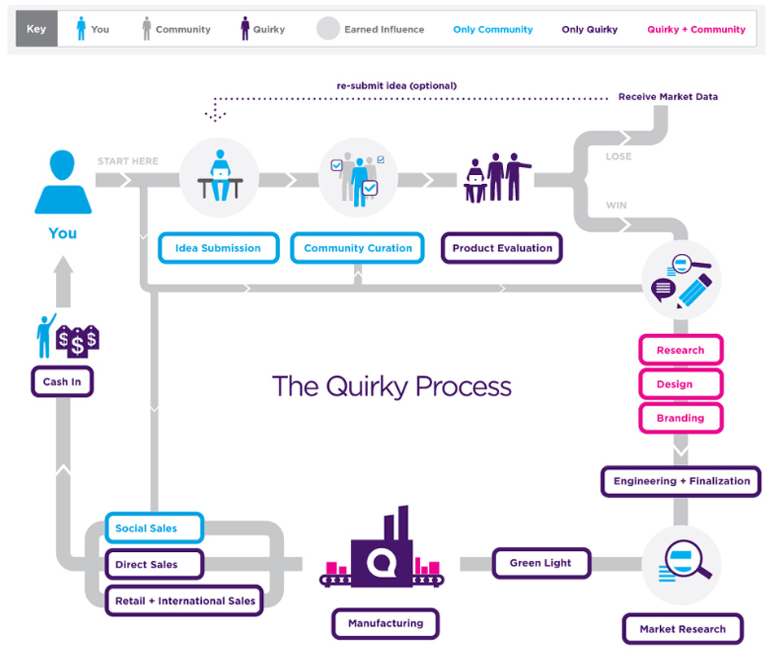

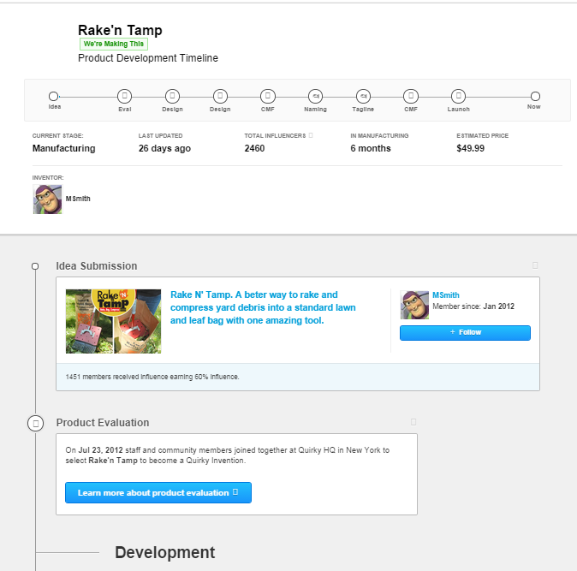

**Quirky innovation process phases**

1. (Challenge??)
2. Idea submission
3. Community curation
   * Voting, Commenting
4. Product evaluation
   * UC, Preval, Live eval, Brainstorm, (Receive market data)
5. Research
6. Design
   * Quirky design, Community design, CMF
7. Branding
   * Naming, Tagline
8. Engineering + Finalization
9. Market research
   * Product launch, Pricing, Pre-order
10. Green light
11. Manufacturing
12. Sales
    * Social, Direct, Retail + international sales
13. Cash in

## Idea submission

Idea submission marks the beginning of the product development process at Quirky. The community members submit their product ideas using a format on the web site. Submitting an idea costs $10. Sometimes Quirky features special challenges, which involve more detailed brief describing the types of ideas that are expected, such as accessories to Apple products. Such challenges may also have free idea submissions. Examples of past challenges and ongoing product categories include:

* Apple accessories
* Everyday products
* 24 h challenge on Apple accessories
* Wink: devices that think for you. Products powered by Imp’s microchip.

Although not mentioned anywhere on the site, I have a feeling that most of all Quirky is about finding good problems for designers and engineers to solve.

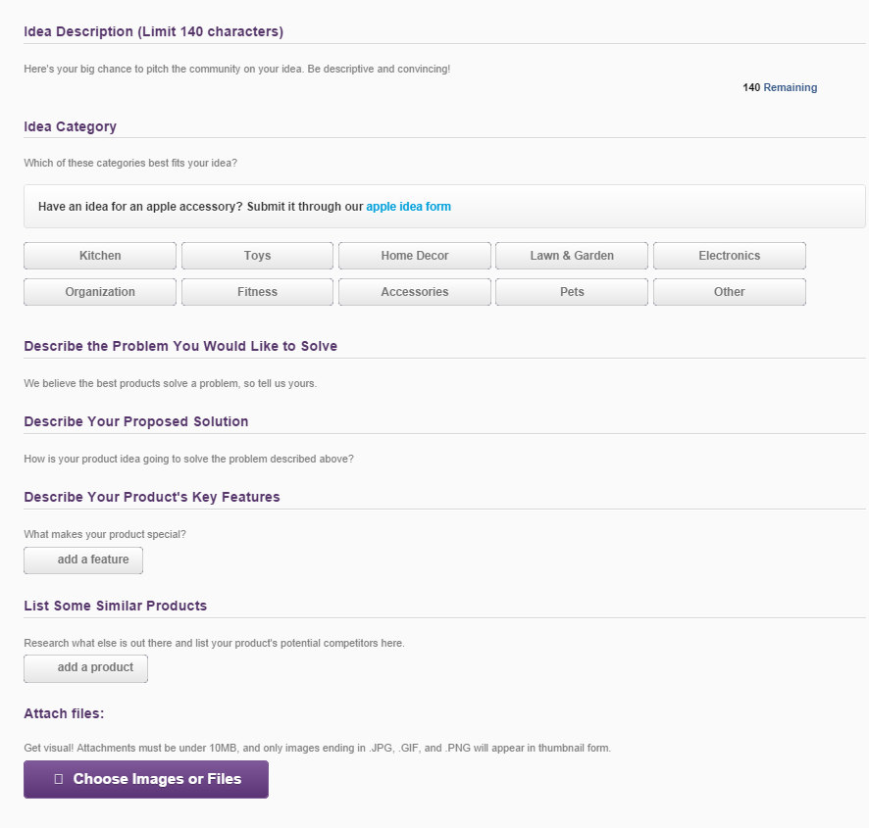

**Rules**

In order to feed out ideas that aren’t thought out Quirky charges a $10 fee for submitting ideas. According to their experience removing the fee causes an avalanche of ideas. In the best case that investment from the user takes the idea from a tiny sketch to a professionally manufactured product. In the worst case the user gets analytics on who likes the idea and extensive community feedback. Users have an option to resubmit a failed idea or use the market research data to make the thing on their own. There is also an option to buy a Pro account for $150, which grants the user free unlimited idea submissions and the right to put one idea submission Under Consideration automatically.

Quirky and submission form provide several constraints and instructions on how to formulate a submission.

1. Limit 3 submissions per 24 h period (Apple accessory)
2. For brief-based projects read the description carefully
3. Patents can be used as inspiration
4. Clearly describe the problem and solution or product and customer
5. Get creative! Sky is the limit
6. We’re hoping that you submit ideas that aren’t just outrageous but also have serious market potential. Make sure your idea is feasible. Focus on viability, marketability and innovation.
7. Try to answer questions pre-emptively
8. Idea description is limited to 140 characters, which happens to be the same as the character limit on Twitter.
9. Submitting drawings is not necessary but it helps
10. Attach, attach, attach. The more you illustrate, the more exited they are bound to get
11. Attachments must be under 10 MB
12. “We love when inventors post videos”

**Tasks**

Here the task is simply to submit ideas for new products.

1. Take your first step to becoming a Quirky inventor by submitting your Apple accessory idea below (limit 3 subs)
2. Submit your genius product idea for only $10! First step to becoming inventor at Quirky. Submit your idea and see what the community has to say!

Submission form asks users to:

* Choose a device and category
* Tell us about your idea (140 characters)
* Just a few more details…
* Add another feature
* Add links to similar products
* Upload images of your idea

**User experience**

I did not submit ideas to Quirky. Despite trying, I did not come up with anything decent.

## Community curation

***How do you decide which idea becomes Quirky's next product?***

*There are two main steps to idea selection: Community Curation and Staff Evaluation. During Community Curation, members of our online community view, vote, and comment on all the Ideas submitted. Quirky Staff then looks through Ideas and, based on many factors including number of community votes and issues raised in community comments, may decide to move some Ideas into "Under Consideration". This is the Quirky Staff "short list" of Ideas that we think are promising. The Quirky Community then gets to submit similar existing products, collaborative edit suggestions, and more comments to Ideas in this short list. The Idea is then evaluated by Quirky Staff and thoroughly analyzed in three areas: Design potential, Marketing potential, and Viability. The Ideas that score high in these areas are then put before Quirky Staff in our Weekly Eval meeting where we discuss the Ideas in depth as a group. Some Ideas are chosen to move forward in the Quirky Development Process, some are not. At the end of the day, though, all Ideas submitted will receive feedback from the Quirky Community, and those placed Under Consideration will receive feedback directly from Quirky Staff.”*

After a community member completes the submission, Quirky community and inhouse experts will evaluate it. While Quirky team makes the final decision, the community helps in deciding which ideas are the best by bubbling up the best concepts.

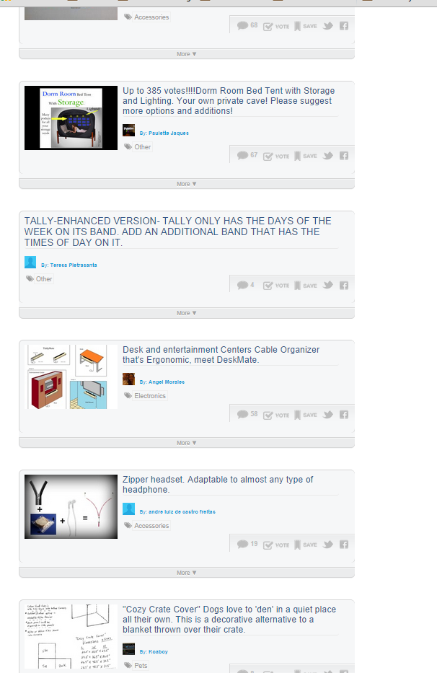

### Voting

Idea evaluation consists of browsing submitted ideas, reading idea descriptions and comments, watching possible introduction videos (rare) and commenting and voting. Ideas can be sorted by their newness, amount of activity, evaluation deadline and by ideas put under consideration by the Quirky staff.

**Rules**

1. Community and in-house experts will evaluate the idea
2. You get 15 votes a day for invention submissions and 3 per project for products in development
3. Cast your votes wisely: We’re counting on you to bubble up best ideas
4. Do the process justice by voting for ideas you really believe
5. You can sort ideas by category and filter on activity, ideas you’ve voted, ideas you’ve submitted
6. Voting is not a joke, but number of votes is not the only criterion for selection

**Tasks**

1. Evaluate ideas. The voting task appears to be actually about spotting promising ideas, or recognize a cool product when seeing one
2. Please check out my ideas, thanks!
3. Can you check my idea?... visit me please I need your advice :)
4. Checking ideas.
5. Browsing ideas: filters include Newest First, Most Active, Ending Soon and Under consideration
6. Scrolling through the newest ideas and voting if I see something good
7. Idea evaluation: browsing newest ideas, checking some of them, but couldn’t find anything good enough to vote for
8. Please vote (comment by an user)
9. Discuss products already in the shop or currently in development. Comment, save, tweet this, share on Facebook
10. Looking forward for your comments
11. View and rate other ideas (automatic feedback from Quirky site)

**User experience**

A big, friendly button directed me to idea evaluation, perhaps because I don’t have my own ideas yet. The task seems to be to spot promising ideas, or recognize cool products when one is seen. There are several filters for ideas, but notably no most popular filter. This is smart, as it reduces the bias in evaluations (independence). Number of votes the ideas have gained is not available either, but I can sort ideas by their view-vote ratio. Violation of independence of evaluations? I have many votes for voting, still 12 left. I wonder how long these will last. Ideas can be browsed in an infinite scroll, which is nice. I always turn this option on. There are plenty of ideas to go through. Finding out ideas can be expanded in place instead of opening them in new tab or window is also handy. Opening ideas in new window tends to break the flow of evaluation and slow down the process.

People have developed different approaches or processes for idea evaluation, for example:

* When I see an idea I like, I comment. When I want to see ideas I like, I select to see commented. Then I can see all the ideas I like and can change my votes
* I use to open all the ideas I voted for but lately it’s so overwhelming the sheer number of ideas that I only open about half to what I vote for
* I skim ideas. If I think they got merit, I will rate them. Then I select options to look at the ones I’ve rated and choose to vote among those

Still the idea evaluation can get overwhelming and boring. According to one user the number of submissions has been getting unmanageable lately, and as a result the quality of feedback ideas get might be decreasing. Most ideas submitted to Quirky are rather bad, and finding enough good ideas to spend all 15 daily votes is a challenge. For example, after 15 minutes of browsing (bored at that point) I had managed to spend only 3 votes, and even those ideas I didn’t like much. It is claimed that people vote just to earn influence in the case that an idea goes through. I was also guilty of this behavior at least once. The Most Active filter helps in finding ideas that the staff might pick, being even called a great predictor, although the “Most Active” sort vote might be stronger at measuring the effect of social proof that ideas the community likes.

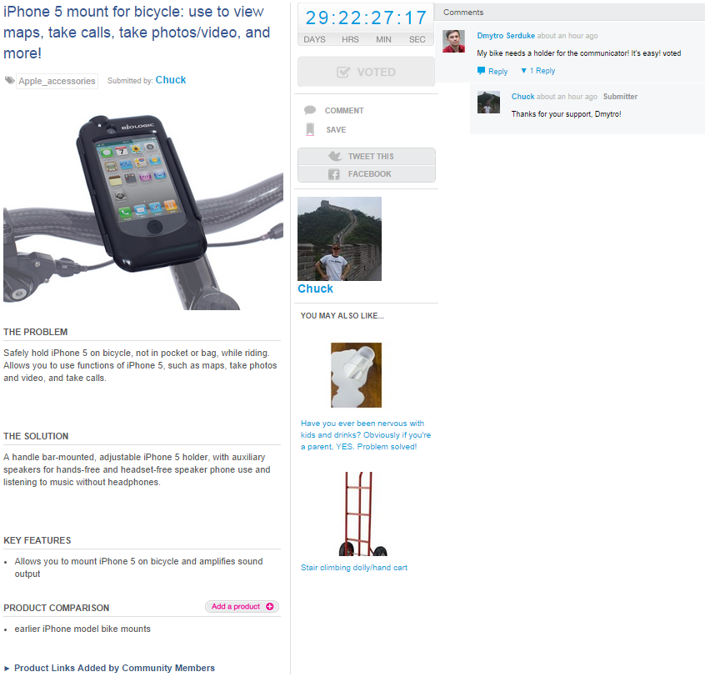

For me evaluating ideas was usually the last thing to do. It feels tedious, ideas are poor and spending the 15 daily votes takes an effort. It somehow feels like I should at least try to spend them all, even to the point where I was trying to get rid of the votes as quickly as I could. I usually browse ideas using the Newest First filter, but if I feel lazy or bored about the poor quality of ideas I switch to Most Active, or sometimes to Under Consideration. These filters have much higher density of decent ideas. It is possible to lose the place where one is evaluating ideas and finding it again in infinite scroll can be difficult. This was sometimes a reason to stop evaluating. Getting all the way to the ideas already seen gives a tiny feeling of achievement, although sometimes there were most of the votes still left.

From the diary:

* *Browsing newest ideas. Trying to find something to spent my votes on. This task feels somehow tedious. So many poor ideas and good ones are far apart.*
* *Voted for airtight lemon squeezer*
* *Ooh! Found out I can expand the ideas from the list without opening in the new page! So handy!!*
* *Voted for posthole digger turned to trench digger. There might be a problem*
* *Voted for soap hook. Simple and easy.*
* *Voted for plant pot with two partitions. Its something that's already done.*
* *Voted for makeup removing pen*
* *Voted for reward cord.*
* *After discovering the expand function the evaluation feels much more bearable. Going to new tab really broke the flow before.*
* *Some of the ideas are just weird: iPhone holder for toilet*
* *Commented on UV light to kill bacteria in shower.*

**Voting experience**

Users have 15 votes per day. I mostly vote using Newest First and Most Active filters. Good ideas are rare. Most content is of poor quality. Using Most Active filter improves the situation somewhat. Idea evaluation gets tedious and boring quite fast.

Quality of submitted ideas is mostly poor. They are often weird and boring curiosities that lack a real problem, or feature only a first-world-problem. They are thus mostly useless. Style is at times similar to Yankee ads. Pictures improve the situation a bit, but it still is difficult to find good ideas among the mass. I could spend 15 minutes browsing ideas and still find only a couple of them good enough to vote, even when the votes are free! Some examples of poor ideas are catnip t-shirt and male pads for catching pee leaks. No wonder why Quirky charges for submissions.

Using the Most Active filter helps somewhat. The idea quality is clearly higher than among the newest ideas. On the other hand the Most Active category introduces feedback loops, which some users claim breaks down the evaluation, as ideas will get lots of votes just because they ended up in the category.

I don’t always vote for ideas, but when I do I try to do so for a reason, although later the reason might have been just to increase my chances of getting influence. Other reasons include having a decent problem, being more creative than the usual ideas, or just following the mass. Quick estimate suggests I voted for at least 60 ideas during my observation period. The count includes only the ideas where I mentioned the voting in diary.

Number of submissions to Quirky is very high, which is mentioned as problematic several times on the forum. Hordes of bad ideas tend to bury the good ones after a day, and within no time idea goes to bottom of the list and number of views drops to zilch. Amount of ideas makes voting tedious. Someone even estimated that assuming 2 minutes per idea, evaluating 75 % of then available 714 ideas would require 18 hours of work! Gained influence probably would not be in proportion to amount of work…

Meaningfulness of votes has been questioned on the discussion forum. A couple of most critical opinions consider the whole community curation to be fake, votes to be completely meaningless, and Quirky just picking ideas based on simplicity of implementation and production. People want a process that works and if idea is not picked they would like some feedback. Main sources of votes are assumed to be Most Active filter, comment count, social media contacts and only then the product idea. In a cynical viewpoint winning depends mostly on getting lucky with audience vote (live eval), pimping like crazy, having someone else win with a similar idea, being a proven success (previous products on Quirky) and only finally by the merits of the idea. On the other hand the critics claim the votes don’t matter, as ideas with only few votes can end up to live evaluation, but on the other hand they say that Most Active ideas with hundreds of votes are selected to evaluation. One guess is that the major sources of votes are lucking to first page of Most Active, voting clubs, social media contacts, friends, hired votes and puppet accounts.

On balance these claims seem to be extreme. There probably is quite lot of variation in the vote counts on ideas ending up to Live Eval, partially for the reasons mentioned on forum discussions. A more balanced opinion states that “votes are nice, but not as important as working on your project to make it the best it can be”. The votes do not count alone, but they are just a part of the data. It is possible to win with zero votes and lose with 400.

People can be sensitive about following the established process and diverging from it may cause protests. In one case a Quirky employee helped a product to get to Eval based on a forum discussion, and that was viewed to be bad manners by some members of the community. Some state disappointment in the process and blame Quirky for failing to “make invention accessible”. The disappointments may partly result from not understanding the process, as one participant confesses. Still the argument about challenges in evaluation system might have some merit. From the outside it appears to be taking a lot of effort to separate the wheat from the chaff and select the promising ideas for development.

Comments and discussion about ideas is usually quite shallow. Someone even considered most of the comments to be a mild form of spam: perhaps a majority of comments is just announcements of having voted the idea, perhaps with some encouragement and suggestion to check the voters ideas in turn. People also might be unwilling to post concerns about products to avoid messing up someone’s dream, as getting a product chosen for development is desperately hard. Personally I did not comment much.

According to some users, it seems promoting/pimping is one part of the reality to get noticed, and could even be considered to be a part of the process.

*“I have my account set up to receive emails from everyone and I get a lot of "Please give my idea a look" emails. I messaged them back and asked for the same, which, with a little help from a friend, some tweets, etc. bumped the idea into the top 3. From there you coast, because people (like myself) often go to the most active and drop votes that are about to expire. Maybe earn some influence too. I never cracked 100 votes doing it the old fashioned way and now I'm sitting on nearly 300. Old record smashed. . I also put "Great idea. Voted" on ideas but that's mainly because I use various technologies to vote and I've lost influence when my vote doesn't show up after it wins. It serves as a proof of vote.”*

Situation may have been different before, before “ass kissing and political correctness corrupted the system” and good ideas stopped bubbling up. According to one opinion, vast majority of comments consists of “Liked it. Voted.” and those comments are supposedly meant as a form of advertising. If people votes for submission, they can increase changes of $ if they leave a comment. People know this and that’s why they do it. As a result, majority of social interaction on Quirky could be considered as a mild form of spam. Different viewpoints also exist. For example one user uses his time between submission and final week trying to communicate why idea should go forward, listens to community and does dozen edits, trying to explain why idea is the best. This kind of behavior is probably closer to how Quirky is supposed to be used.

## Product evaluation

### Under consideration

Quirky staff picks ideas from community curation and puts them under consideration as a step towards more thorough evaluation by the staff.

*Every day, the Quirky staff goes through all of the ideas submitted to our website. Everyone here is responsible for finding the very best ideas with the most potential. When someone finds an idea that they want to share with the rest of the staff, they pull it out of the pool of submissions and put it under UC, so that it can be presented to the Quirky staff for review. . One of two things will happen after your idea is reviewed; either your idea will be chosen and we will move to EVAL (We’ll call and let you know), or your idea will not move forward and we’ll reach out to you by leaving our reasons for not choosing your idea in your feedback section of your page (underneath your submission and above your idea’s comment section) with some additional information about resubmitting ideas and some ways to improve your ideation.*

**Rules**

1. Our priority as staff members is to help company find the best products, whether through great process or ugly hack. Having the simplest, cleanest rules is not absolute priority, making invention accessible is
2. All staff have ability to put any idea under consideration
3. Votes help with an idea’s visibility, but are not the deciding factor. It doesn’t matter how many votes you have. If Quirky finds an interesting market, they will pursue
4. All ideas will stay under consideration for a maximum of two weeks and are reviewed by two committees, but go to Eval only once
5. Idea has not been live for 2 days before it is eligible for UC. The 48 h restriction gives the community a chance to comment & vote
6. Team does not give feedback on every idea, only those that go UC

From the community’s perspective the level playing field regarding the process seems to be important. Quirky team members who get paid should not expect free input from the community (as opposed to input that generates influence). This viewpoint surfaced in a discussion thread where a Quirky employee helped an idea to get to the Eval, causing an user to wonder if his idea would get the same extra time and review that the other idea received.

**Tasks**

1. Select ideas to Preval: Every day Quirky staff goes through all the ideas submitted to website

**User experience**

### Preval

Preval committee determines which ideas merit further discussion (and eventually a spot in eval). It convenes for 2-3 hours each day Monday to Wednesday to discuss ideas in UC. Preval committee is organized in teams of 5-10 members and selects 8-15 ideas with most potential to weekly eval. Participants are selected from a rolling roster and feature a diverse knowledge base. Normal week ideas looked on Monday are anywhere in their last 7 days of expiration. Preval committee looks through the full list of ideas in UC, starting with ideas discussed last week or with highest votes. In Preval Quirky looks mainly at 140 character pitch description and image. Focus is on ideas on their last week prior expiration. Large categories are split in two. Each submission is discussed at length from many perspectives. By Wednesday preval committee has a list of strong contenders and maybes, from which it selects concepts to be discussed in live eval. Without review of each idea staff runs risk of skipping over great ideas.

**Preval process**

*In short, the Preval process is handled by way of committee: each week, a group of Quirky employees is assigned to take part in a series of pre-evaluation meetings. Staff members are selected from a rolling roster, but the groups are kept varied to ensure a diverse knowledge base: a mix of different specialities and skill-sets is key. For the last Preval series I attended, which occurred two weeks ago, the roster was as follows:*

*- Kate Vallon (Design)– Julie Andress (Operations)– Nancy Chen (Retail)– Michael Lacy (Tech)– Katherine Druback (Community)– Baron Nagy (Community)*

*The Preval committee convenes for 2-3 hours each day, Monday through Wednesday, to discuss the ideas currently Under Consideration, and select the 8-15 with the most potential to be moved to that week’s Eval. Each groups is organized by Gaz Brown, Quirky’s Head of Design, who also sits in on each meeting to lead the discussion.*

*The structure of each meeting is straightforward: the Preval committee looks through the full list of ideas Under Consideration, starting with the ideas that were first discussed by the prior week’s committee (each idea remains in UC for two weeks, to be reviewed by two separate committees). Each submission is discussed at length, and from many perspectives: design, originality, marketability and technical viability all come into play, with each committee member leveraging his/her own background. For example, Mike Lacy’s experience as a cyclist and father makes him a perfect candidate to discuss bike products and toys, while Nancy Chen’s retail know-how qualifies her to discuss an idea’s market potential. If none of the committee members feel they are qualified to discuss a certain product, we won’t hesitate to refer to outside expertise: when discussing ideas related to tools and hardware, we would frequently refer to Richard Ganas, the designer in charge of QHQ’s workshop.*

*While the first meeting of each week features a full run-through of the ideas that are in UC, the list of potentials grows shorter with each subsequent meeting, and the discussions more in-depth. By Wednesday’s meeting, the Preval committee will have generated a list of strong contenders (and a larger list of maybes) based on what the team found compelling, and what sparked an interesting discussion. At this point, the Preval committee must decide why each contender deserves to be discussed in Eval: some concepts have clear and captivating virtues, but wild cards may be chosen if the committee discusses them at length, and believes that the concepts are worthy of an Eval debate. During my own Preval experience, the Bicycle Brake Signal was one of the ideas that seemed an obvious choice, as motion-activated brake lights for bicycles did not exist, and the submission seemed perfect for our growing line of bike products. In contrast, the Self-Cleaning Lawn Mower Attachement was a concept we were more apprehensive about. The solution was solid, but we weren’t sure how wide-spread the problem was, so we decided to bring it to Eval to see what the community had to say. While the submission received enough member/staff support to be picked for exploration, other wild-card concepts have invoked a more negative reaction, like the wasabi stirrer discussed at last week’s Eval. This doesn’t necessarily mean that the idea should not have been brought to Eval: the Preval committee decided that this could either be a new universal tool or a dud, and the community gave them the answer.*

*I hope that this brought a bit of clarity to the process that happens each week prior to live Eval. If you have any further questions, please don’t hesitate to give us a call at 212-389-1390, or email us at questions@quirky.com. In addition, if you are confused as to why a certain UC submissions made it to Eval yesterday, or why another didn’t, please feel free to email me personally at baron@quirky.com. I’ll be happy to respond with feedback from the Design team.*

**Monday Meetings**

It appears there is also additional Monday Meetings to pick more ideas in UC. During Monday meeting the committee looks at picture and headline, opens interesting ideas and discusses them thoroughly. If several people find an idea interesting it is put in UC.

*We heard your thoughts about how every idea should get its fair shot and how, without a review of each idea, the staff runs the risk of skipping over some really great ideas.*

*In order to solve for this, the Quirky staff recently organized into groups of about five to ten people. This split is based on each staff member’s experience, passion, and what department they work in within Quirky. For instance, your Head of Community Steven Shaw is passionate about cooking and kitchenware, so he was placed in a Kitchen group. The categories are broken up the same way that the ideator is allowed to categorize his or her idea, such as Accessories, Electronics, Garden, Decor and so on.*

*Each group has been meeting every Monday for the past month to go through all of the ideas that have been submitted in that group’s category, starting with the highest-voted ideas. The groups focus on ideas that are in their last week prior to expiration, so as to allow time for community curation. For some of the larger categories, we split the category between two groups.*

*Every meeting room is equipped with a large flat screen TV that allows every team member to follow along closely. During the meeting, we first look at the picture and headline of the idea submission.*

*Often the group can tell right away if the product is not going forward, for example see here, but if an idea piques a group member’s interest or has substantial community support, the group will click on it to learn more about what the invention is and what problem it is trying to solve. The groups thoroughly discuss these ideas, sometimes bringing up past experiences where the invention could have helped or why they think the product will be a success at retail, or the reality of the problem that the ideator identified. If several members of the group find that the idea is interesting the group will place that idea Under Consideration.*

*Some questions that we encourage an ideator to ask before submitting are:*

1. *Does this already exist?*
2. *Have you checked Google and Amazon for similar products?*
3. *Who would purchase this product?*
4. *Have you done any market research or surveys?*
5. *Will this appeal to a broad audience or a niche market?*
6. *Does this solve a problem?*
7. *Will this product improve people’s lives?*
8. *How does this offer any notable improvements over what is already available on the market?*
9. *In a world where so many products are competing for space and profit, why would someone choose to purchase THIS product?*
10. *Does it make people wonder, “Why didn’t I think of that?!”*
11. *How do you know this will work? Did you create a proof of concept or prototype?*
12. *Do you have a video showing your concept or prototype in action?*
13. *Do you have experience in this field?*
14. *Do you have experience working with the target audience for this type of product?*

*For ideas that the group expanded but did not want to place Under Consideration, your trusted Community Ambassadors have been relaying some of the spoken commentary in the comment section of your submission. This may come in the form of a question for you, the ideator, or as a suggestion that the group thought would improve the idea. We hope that this will promote conversation and collaboration amongst community members.*

**Rules**

1. Preval committee determines which ideas merit further discussion (and eventually a spot in eval)
2. Preval committee convenes for 2-3 hours each day Monday to Wednesday to discuss and select 8-15 ideas with most potential to eval
3. Each week group of 5-10 staff from a rolling roster are assigned to take part in series of pre-eval meetings
4. Does is discuss newest ideas in UC to give same initial discussion period for old and new ideas
   1. Refer to outside expertise if feel not qualified to discuss certain product
5. At times of lack of content, same day ideas may be picked, but this is a situation that is strived to avoid
6. Ideas moved into UC on Thursday are not considered that week, but moved to next week’s batch
7. By Wednesday preval committee has a list of strong contenders and maybes and selects concepts to be discussed in live eval

**Tasks**

1. All the Quirky staff go through ideas to find them for weekly Eval

**User experience**

### Live Eval

Every Thursday at 7 pm Quirky crowns brand new inventors through their product evaluation process. 10-15 ideas are reviewed live, out of which usually 3-5 are selected to be designed and likely commercialized. Apparently all the Quirky staff participate along with occasional guests and the event is streamed live over the internet. The community can participate through chat or different voting tools. Video recordings of past events are available on the website. The evaluation process is quick and efficient. Ideas are shortly presented along with a summary and statistics (votes, etc.) projected on the wall. Usually the CEO hosts the event and solicits different viewpoints from the audience. After a few minutes of debate the room votes by raise of hands on “Should <name> become a Quirky inventor tonight?” Sometimes people are encouraged to vote during the voting. There are three possible decisions:

1. Not building it
2. Explore or come back to it later
3. Build it

If the decision is explore, the audience gives a single clap. Decision to build something elicits solid applause. The decision making appears to be fast and effective, reaching reasonable consensus. The tools the community can use during the evaluation are chat, sentiment meter, thumbs up/down and a pricing tool. Sentiment meter measures how much the community likes or hates an idea. Thumbs up / down is used to ask for an opinion on a proposition. Pricing tool is used to evaluate how much the community would pay for the product, which helps to determine if idea is good and people are willing to pay for it. After the votes are tallied they are displayed and discussed by Quirky staff. After a decision to build something the staff go through the old archives to find out if someone had suggested something similar before and would deserve influence.

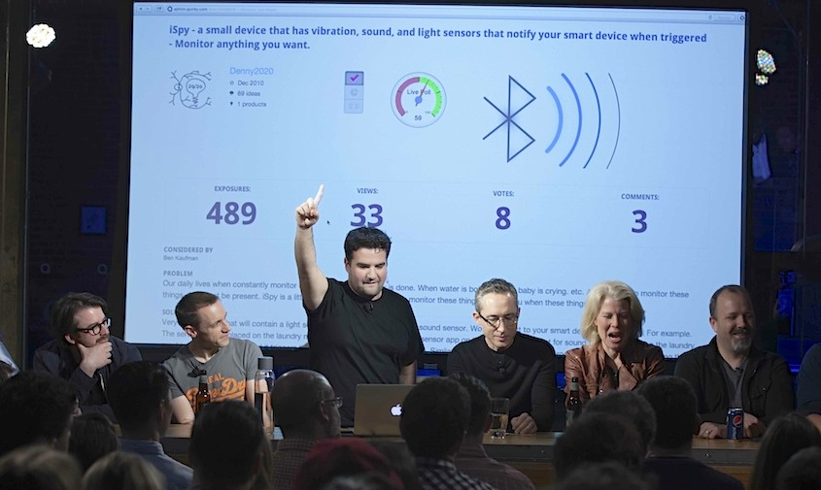

**Rules**

1. Every Thursday at 7 pm we crown brand new inventors through our product evaluation process. 3-5 winners selected from 10-15 ideas.
2. Selected products get designed and likely commercialized
3. Soliciting different viewpoints
4. After a few minutes of debate the audience votes
5. Voting by raising hands. The voting can be manipulated and people can be convinced to change their minds
6. Possible decisions:
   1. Not producing
   2. Explore (at least for an hour)
   3. Produce
7. After the decision explore gets a single clap from the audience while decision to produce gets solid applause
8. After selecting an idea they go through archive in case some people have submitted similar ideas and deserve influence
9. After eval it does not matter if the engineer didn’t like it. Community voted for it and it will be made

**Tasks**

1. Just head to Quirky.com/live this Friday at 3 pm ET and be ready with your questions or post in comments
2. Check out last week’s recording
3. Decide the fate of chosen products by participating in the Quirky eval process.
4. Cast votes and make your voice heard
5. Vote yes or no on a proposition at eval
6. Enter the price you’d pay for a product
7. Sentiment meter: Use slider at the top right of screen: like to right, hate to left
8. Watching live evaluation
9. Watching evaluation video recording

***How Voting Works***

*Decide the fate of chosen product ideas each week by participating in the Quirky Eval Process. Cast your vote for the idea in discussion and make your voice heard on the chat, to help the Quirky crew crown the next inventor.*

***Types of Votes***

*Sentiment meter. Use the slider available at the top right of your screen during the eval broadcast. Like the idea? Slide it to the right. Love the idea? Slide it farther to the right. Hate the idea? Go left. Responses are calculated and displayed in real time.*

***How much would you pay?***

*This flash polling tool allows you enter the price you’d pay for a product. The average is displayed as soon as the polling is closed, helping to determine not just whether an invention is a good idea, but also whether people will pay enough to make it viable.*

***Thumbs up, thumbs down.***

*Vote yes or no on a proposition at eval. Would you use that sponge idea to clean your windows? Let the community know and inform the final decision.*

***Seeing the Results***

*After a vote is tallied the results are displayed on the live stream and discussed by Quirky Staff.*

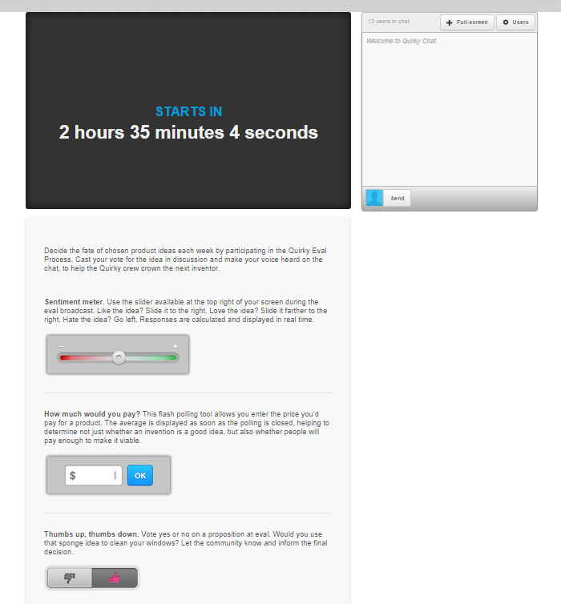

**User experience**

Quirky Live Eval is a bit like Al Jazeera stream, but for product development. Live chat is going on and has 40-300 users. They have it all! Cool company! On the other hand, the chat appears to be mostly useless. There’s definitely no time to follow what’s going on in the chat. 50-350 people are viewing the eval. Watching evaluation. Highly enthusiastic CEO explains how it works. Really rapid fire: “You like it… next!” “Do you have objection? Speak!” “Anyone else negative opinion?” The CEO asks often for opposing opinions, someone liking or not liking the idea, depending on what others think. I like the decision making approach with fast discussion and voting by hands. Once I saw a different decision: The community liked an idea at 70 % level. The CEO didn’t seem to listen to the audience. After a quick vote he went for the community decision.

*2083 exposures, 665 views, 592 votes and 73 comments*

*It might be possible to collect some data on these numbers. Difficult, but possible. Perhaps not worth the hassle, because I cannot get data on ideas that were not selected*

*"76 % of community like it so we go to community!" Asking community opinion from Berend*

*Then rapid fire with experts*

*One of the experts wanted to know how much community would pay for it. They have functionality to do that live during the Eval. Price shown on screen in real time, while audience comments*

*50/50 vote. Community decides. If more than 50 % of community like it in the end of count down, they will make it. Pie chart locked to more than 50 %. Decided to make it.*

*Answered the questions.*

*“It started. High level of enthusiasm CEO (?) explaining how it works. They're going to go trough 53 pre-selected ideas. 90 seconds for each ideas.*

*Divided to cases and non-cases*

*Cases first 30-something ideas.*

*Really fast-fire: "I think this is a no-brainer…" "you like it. next."*

*around 250 people participating online*

*There's the expert panel, audience, chat and voting thingies for people online*

*Found the like/unlike meter.*

*"Do we have an objection? Speak!"*

*"Anyone else have an opinion? Negative opinion?"*

*Current idea is nicely shown on the top of the page. This is cool.*

*Process is somewhat like this:*

* *Short presentation of idea*
* *Expert opinions*
* *Some opinions from audience*
* *Negative opinions, if any*
* *Community opinion*
* *Vote with cheering*
* *Decision: pass, accept, bubble, explore*

*Definitely no time to follow what's going on in the chat*

*Somewhere fab.com was mentioned. Is this challenge (or whatever they call it) a collaboration?*

*Not many liking an idea. "Who likes it? We're going on to vote. Next."*

*350 people watching and about 300 on chat*

*Time goes up for the idea, there's the bell. "Oh, vote now!" Strict policy on time.*

*Site crashed a bit. Chatlog is gone :(*

*Fab seems to be a design shop. A collaboration with Quirky would make sense.*

*Chat seems mostly useless for decision making process*

*Ben is asking first a round of comments from the panel, then couple of comments from the audience. Possibly check what the chat thinks, and then moves on to vote. The vote decides whether Quirky will make the product or not.*

*Ben asks often for opposing opinions, someone liking or not liking the idea, depending on what others think*

*I wonder how they select the shortlist for evaluation*

*Gotta catch my plane. Have to stop watching, even though they are still evaluating ideas.”*

### Brainstorm

Brainstorms are Quirky’s another weekly live event, during which Quirky design team discusses a newly selected idea and explores it’s design directions. Community can participate through chat and the event is streamed over the web. Typically brainstorming results in a mindmap.

*If you’re new to brainstorms, allow us to explain. Every week, QDS blows a few product ideas wide open to kick off the design process. You can take part in that. Here’s how:*

1. *Topics are posted above. In your wildest dreams, what would be the perfect way to make that product? What should it do, and what problems should it prevent? It’s a brainstorm, so anything goes*
2. *Visit the QuirkyLive page at 5pm ET (normally 6pm ET) on Wed. Log into your Quirky account to join the discussion and share your input through the chat.*
3. *Can’t join the live brainstorm? Be sure to add your comments here before the start time, and we’ll have them in mind.*

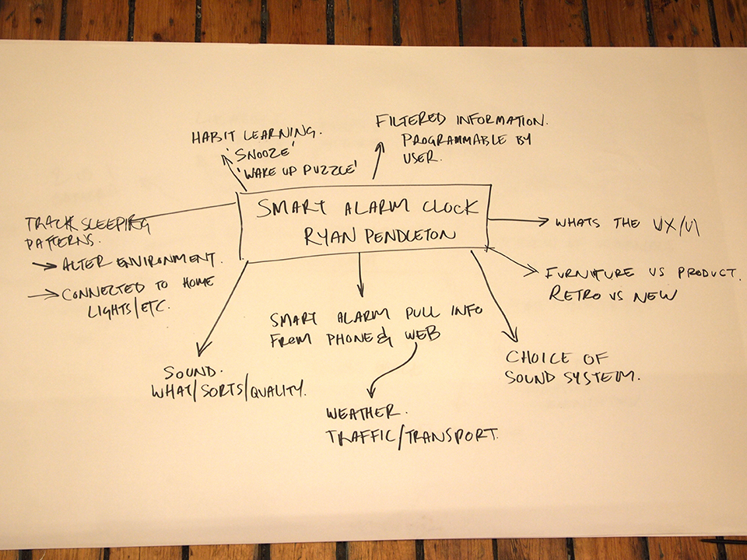

**Rules**

1. Weekly previews before the brainstorm
2. Brainstorm is a routine practice and a part of weekly schedule
3. Brainstorm blog post format:
   1. One-off intro
   2. 3-4 products
   3. Copypasta instructions

**Tasks**

1. Brainstorm is about exploring the concept around the door space
2. We focused on expanding on his original idea and how kids would interact with it

**User experience**

Watching live brainstorm. I don’t feel like commenting. The chat feels unfocused. Most of the value is produced by the people around the table. The chat is an add-on. Research tools and polls in brainstorming interface would be nice. Now it’s just about reading chat and seeing designers work. This experience is echoed in some of the criticism on discussion forums states that community is only allowed to watch but not participate to brainstorm. Results of surveys are rarely incorporated and name and tagline are only about marketing. As a result community has very little effect on the final product.

## Receive market data

**Rules**

**Tasks**

**User experience**

## Research

In research phase the community is usually asked to answer short surveys or questionnaires about the product under development or behavior of potential users. These tasks are usually simple, a more effortful ethnographic research project being an exception: “The purpose of this project is to better understand how Pod Power would be used in a real world setting. To this end, we’re asking members to recreate a potential use case, using string and tape as a substitute for the actual product.”

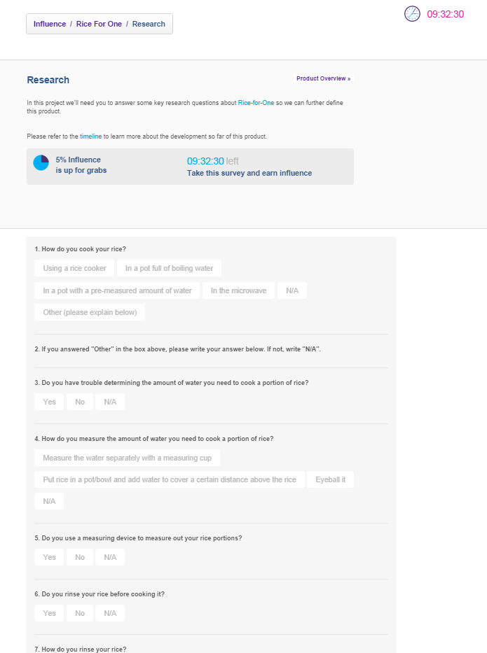

**Rules**

1. Try to keep up with the research phases when they open up. Each participant receives influence for contributing valuable data regarding the design
2. In this project we’ll need you to answer some key research questions about <product> so we can further define this product
3. 5 % influence available, 09:32:30 left to take this survey and earn influence
4. Before you complete the survey, we need you to tell us a little more about yourself
5. Please refer to the CMF phase for a general idea of how this product will look
6. Please answer all questions
7. You’ve completed enough of this survey to earn full influence!
8. View results. 955 responded earning 5 % influence
9. Ethnographic research task as a special case: much more complicated rules than in usual tasks

**Tasks**

1. Answer some key research questions about <product> so we can further define this product/project
2. We want to ask some general research questions about the idea. We’ve also incorporated more specific questions straight from the inventor of this product
3. Ethnographic research phase for pod power: Recreate potential use case
4. Answered research questions

**For something completely different: ethnographic research task:**

*The purpose of this project is to better understand how Pod Power would be used in a real world setting. To this end, we’re asking members to recreate a potential use case, using string and tape as a substitute for the actual product. Here’s how it works:*

*1. Find an outlet somewhere around your home, preferably in an area where you frequently use electronics (bedroom, office, living room, etc.). Tape the end of a string to the outlet, to represent the base of the plug.*

*2. Next, locate a spot nearby where you would like the first pod to be placed. This can be next to a chair, under a desk, or along a countertop: anywhere you wish you had an extra outlet handy. Extend your string to this location, and mark it with a piece of tape. The string itself should be relatively straight, but it doesn’t have to be taut.*

*3. After marking the first pod, look around the room for other potential pod locations, extending the string to each in turn and marking the spots with tape. You can look over the launch images for Pod Power to get a better understanding of how the product can be used.*

*4. Once you’ve placed three to five pods around the room, take a photo of the complete layout (try to include as much of the setup as possible, but don’t worry if certain parts don’t fit in the frame). After this is complete, retrieve the string, remembering to keep the various pieces of tape attached. Using a measuring tape, measure the distance from the end to the first piece of tape, and the distance between each subsequent piece.*

*5. Submit these measurements to the Ethnographic Research phase along with your photo, and boom! Guaranteed influence. As a reference, your submission should look something like this:*

*End of String to First Pod: 35 inchesFirst Pod to Second Pod: 31 inchesSecond Pod to Third Pod: 38 inches*

**User experience**

Checking research phase. It has one product now. Seems like a survey. Smart. Answering a survey. They ask a bit too detailed demographic questions. I earned influence from answering the survey.

The research phase is mostly about filling in questionnaires from user’s perspective. Sometimes it was difficult to know whether I had earned influence. Quirky incorporates at times questions from the inventor to their surveys, but these questions tend to be weird and probably do not give much useful information to the inventor. Inventor questions also make the surveys long. Occasionally Quirky adds funny details, questions or answer options to their surveys, such as interest scale going from “snoozefest” to “peed my pants”. I once answered a questionnaire about a wrong product.

## Community Design

In community design and refinement phases Quirky is looking for and evaluating concepts that help inform their design direction. Depending on the case the community may submit design ideas for a particular product or product feature, and vote and comment on them. Organization of these tasks varies somewhat: sometimes Quirky has done the alternative concepts already and the community only votes, sometimes there is first a submission phase for community designs and after that the community votes, and sometimes the submission and voting phases occur concurrently.

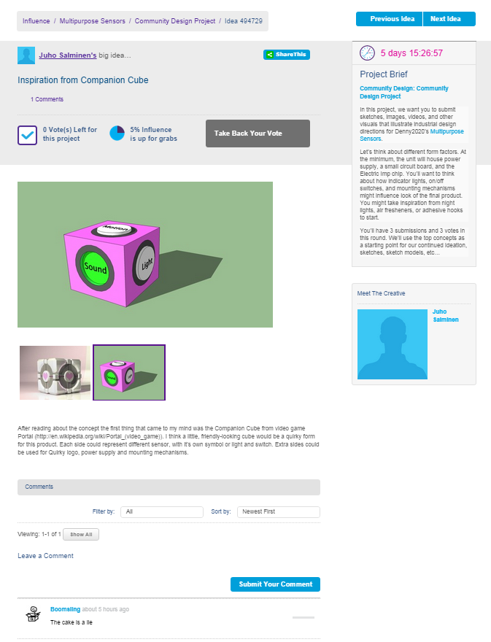

**Rules**

1. We have disabled comments and voting for duration of this round. We will re-open after initial 7 day period for commenting and voting, but not submitting

**Submit**

1. We will choose the strongest concepts to help inform our design direction
2. We will take the top ideas as inspiration towards the final design. Please take a look at the original submission before you get to work
3. Before you begin, check out the research phase results to get some ideas on what type of concepts the community is looking for
4. Each community member is allowed to submit one concept
5. Ideas pouring in create pressure to submit half-baked concepts

**Vote**

1. During each project, you’re given a certain number of votes. Use them to push forward the ideas you truly believe in. If one of chosen wins you’ll earn influence x10
2. Number of votes on each project is limited (usually 3), but users can take back votes if they change their mind: “Vote for this” and “Take back your vote”

**Judgment**

1. In judgment (by Quirky). Community submitted ideas, 60 % influence
2. Quirky declared they aren’t selecting the ideas they use in product but ideas that helped move the development along

**Tasks**

1. The task is split: first subs, then voting & comments

**Submit**

1. Created a concept and voted for micropayments for yourself
2. Multisensor community design: I just subbed a design! Drawn with Sketchup! That was fun!
3. Submit sketches. We will use the most compelling sketches as a starting point for final design
4. Submit sketches, images, videos and other visuals that illustrate design directions for <product>
5. Have a great design for this project? Submit your idea and see what the community has to say!
6. Refine submissions from other users

**Vote**

1. During each project, you’re given a certain number of votes. Use them to push forward the ideas you truly believe in
2. Community design project: Help choosing between three different concept directions for this product. Vote for your favorite. Feel free to comment
3. Please vote on the concept you like the best. Also, if you have any comments about either of the designs, be sure to share!

**User experience**

Checked the design phase. They’re asking to submit prototypes, sketches or designs. Very smart! After reading the concept the first thing to come to my mind was the Companion Cube. I’m trying to make a sketch with Sketchup. Just submitted a design! That was fun! I also voted for my own design. Unfortunately many other users had had the same idea. I voted for them so cube designs would have better changes, and if one of the passes I might get some influence. I don’t like to do design tasks on the app. It seems somehow confusing, like a find a pair game. It lacks an easy way to explore suggestions. The design part of the process seems to be creating “similar submissions” issue. There is already 57 suggestions, and it is not many days since I last checked the site. The user base must be much bigger than in OpenIDEO. In another case there are 77 pages or 770 suggestions. This site really turns around fast! I browsed this mass of ideas in random order and voted for three. Ideas I’ve voted for appear on top, and I can drop votes if I find something better. It is kind of a search algorithm, which stores the best result found so far. Smart platform! After scrolling through the suggestions I vote for the original. Achievement complete! Another time I went through all the suggestions and voted for three of them. I wasn’t particularly interested in any of them, but at least I got something done. If the number of suggestions was not overwhelming (11 pages of options still doable), I usually quickly went through all the options during voting to find the best ones.

Community design phase appears to have some sources of possible bias. Comments to suggestions are visible, and at least once I almost cancelled my vote when I found out that somebody had given a negative comment. Often I avoided biasing myself by consciously avoiding looking at the comments before voting.

### Refinement

In refinement phase the community votes on a few design options created by the Quirky staff. It is very similar to CMF phase, and shares commonalities with Community Design phase too. The designs that are evaluated are done by the Quirky staff, and there are only a few options, in one case only two.

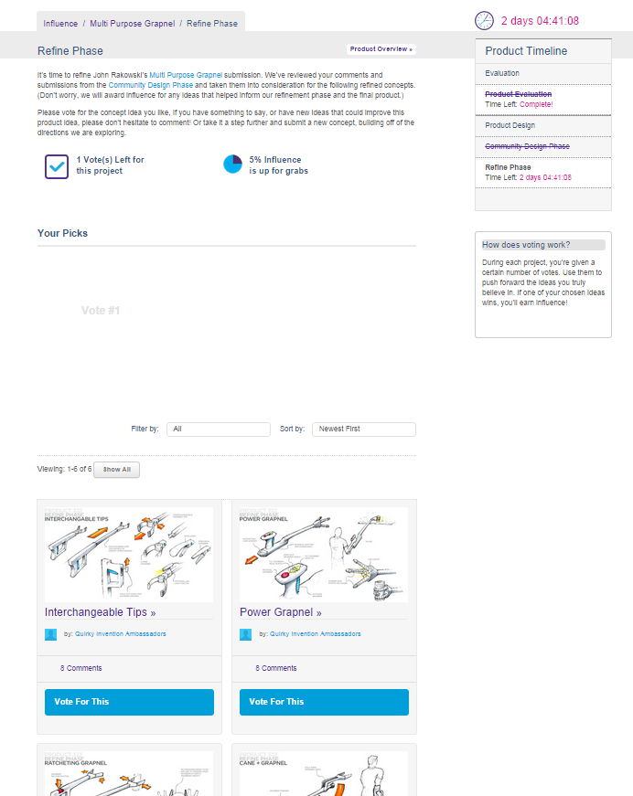

**Rules**

Similar to CMF phase.

**Tasks**

Similar to CMF phase.

1. It’s time to refine the concept for <product>
2. Over the past few months, we’ve been refining the design for pod power (Quirky staff)
3. My task is to choose my favorite concept from the suggestions made by Quirky designers
4. Six alternatives made by Quirky. Task to select best one. I have only one vote

**User experience**

Similar to community design and CMF phases to the point I didn’t notice the difference during observations and could not recall what the refinement phase was like.

### CMF

Color, Materials and Finish phase is about choosing the aesthetic details for the product under development. Quirky provides a few options, and the community gets to vote for its favorites.

Before we launch, we need your help deciding what color scheme would work the best. CMF: In this project we’ll be choosing the colors, materials and finishes for the finalized Rice-For-One. Please refer to timeline for info.

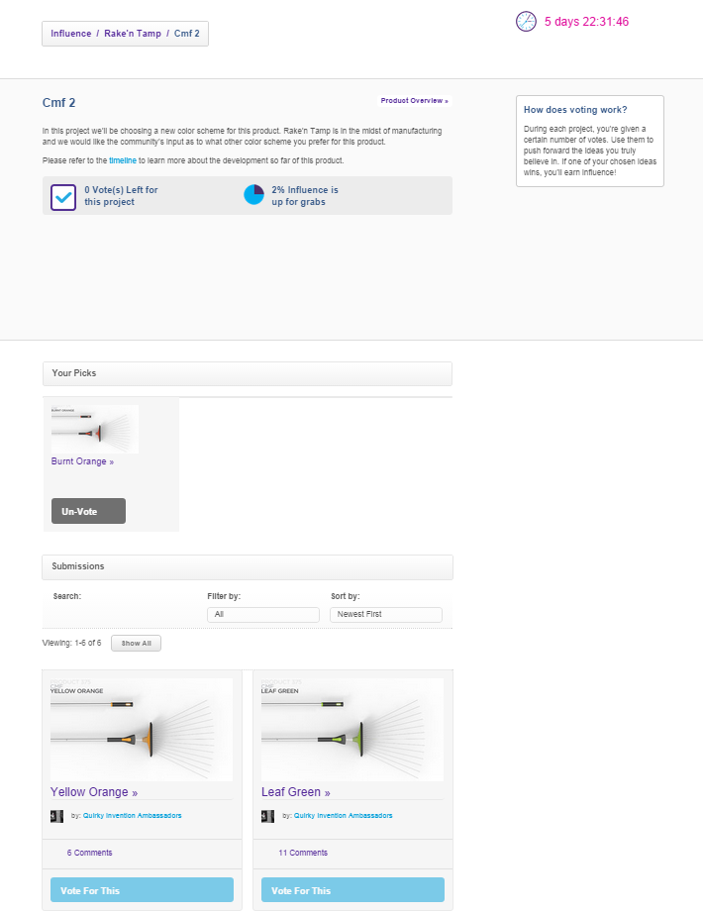

**Rules**

1. In this project we want you to vote on the final colors for this product. Vote for versions you like best. Leave comments and suggestions
2. Selecting CMF: In judgment (by Quirky staff) Community voted on ideas earning 5 % influence

**Tasks**

1. Help us choose the finished look for this product
2. Feel free to leave your ideas in comments
3. Vote for version/ the color scheme you like the best, and make sure you leave comments and suggestions

**User experience**

CMF phase is mostly about voting, and sometimes commenting on aesthetic options. These tasks are easy. Bias is possible also here: in one case I voted for burned orange color scheme. It happened to have the most comments, but I only noticed this after voting. In another time I was affected by the number of comments. After the winning scheme is announced by Quirky the users may feel they picked the wrong option if their selection does not match Quirky’s decision.

## Branding

### Naming and tagline

Naming and tagline tasks changed during the observation period. At first they resembled the design task with submissions and voting, but it was then changed to compare two –approach similar to Wikisurveys at All Our Ideas. This version is based on ELO-rating from chess tournaments, and it is created by comparing two options side by side at the time and then choosing the better one as a winner.

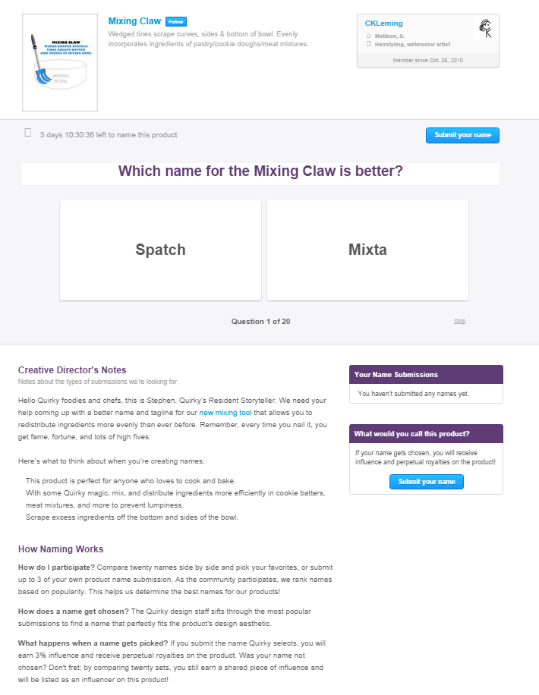

**Rules**

1. It’s time to name the kitchengami and we need your input!
2. Product naming phase lasts usually about 3 days and each user is able to submit 3 names
3. Here’s what to think about when you’re thinking up names and taglines
4. Tagline: a couple of words, not shorter than name. It needs to embody everything that Quirky stands for as a brand, be eye-catching and ‘sticky’.
5. Rules on names posted on blog and forum: Naming brief!!
6. Don’t include the word Mac or the letter I at the start of your names
7. Algorithm prevents same spelling names to be submitted. Couldn’t suggest a name, it had already been suggested
8. Naming game: Vote 20 times to gain 2 % influence / number of voters. After that it is possible to continue, but no more influence
9. Skipping reshuffles the cards
10. Naming game: Skip option just gives next evaluation. No punishment wikisurvey style
11. You’ll earn valuable influence after voting on 20 names
12. You’ll earn valuable influence after voting on 20 taglines
13. There’s an option to continue voting
14. We reserve the right to not pick a tagline if it does not make the cut
15. Naming project: In judgment

*It's time to name the Mac Mini Flip Stand and we need your input!*

*You'll earn valuable influence after voting on twenty names and have a huge impact on a future Quirky product.*

***How Naming Works***

*How do I participate? Compare twenty names side by side and pick your favorites, or submit up to 3 of your own product name submission. As the community participates, we rank names based on popularity. This helps us determine the best names for our products!*

*How does a name get chosen? The Quirky design staff sifts through the most popular submissions to find a name that perfectly fits the product's design aesthetic.*

*What happens when a name gets picked? If you submit the name Quirky selects, you will earn 3% influence and receive perpetual royalties on the product. Was your name not chosen? Don't fret; by comparing twenty sets, you still earn a shared piece of influence and will be listed as an influencer on this product!*

***How Tagline Works***

*How do I participate? Compare twenty taglines side by side and pick your favorites, or submit up to 3 of your own product tagline submission. As the community participates, we rank taglines based on popularity. This helps us determine the best taglines for our products!*

*How does a tagline get chosen? The Quirky design staff sifts through the most popular submissions to find a tagline that perfectly fits the product's design aesthetic.*

*What happens when a tagline gets picked? If you submit the tagline Quirky selects, you will earn 3% influence and receive perpetual royalties on the product. Was your tagline not chosen? Don't fret; by comparing twenty sets, you still earn a shared piece of influence and will be listed as an influencer on this product!*

***Tagline Project***

*Hey there Quirky Apple fans, this is Stephen, Quirky’s Resident Storyteller. We need your help coming up with a better name for our Mac Mini Flipstand. Remember, every time you nail it, you get fame, fortune, and lots of high fives. Here’s what to think about when you’re creating and voting for names:*

*Mac Mini Flipstand: You love your Mac Mini mounted on your wall as your hub for connectivity and innovation. Now, thanks to inventor Paul Patrocky, we’re introducing the Mac Mini Flipstand:*

*With its genius swivel, your cords will never get tangled or yanked out!*

*Easy wall mounting and built-in cord management for extra convenience.*

*It accommodates all of your cords, so they can spread out in many directions.*

*We’re targeting Apple lovers like you! But, don’t include the word Mac or the letter i at the start of your names (e.g. iPhone) because we don’t want to face our legal team’s wrath.*

*Check out this video for more details on the product:*

**Tasks**

1. Have a great design/name/tagline for this project? Submit your idea and see what the community has to say! Help coming up with a better name for our products
2. Come up with the product tagline for the packaging of the doggie drinking sprout
3. Briefs for naming: Telling community exactly what Quirky is looking for
4. Start choosing names or submit your own name. Compare twenty names side by side, or submit up to 3 of your own product name submissions
5. Complete! Submit your name. Participate on other Quirky products to earn even more influence
6. Quirky design staff sifts through the most popular submissions to find a name that fits the product design aesthetics

**Advice on creating a name for a product:**

1. Write down everything that describes the product: target, functions, animal sounds, etc. Get a list of all the factors that go into name. Photos from magazines
2. Select around 20 best
3. Come up with names based on those factors
4. Mix words, borrow from other languages
5. End product: 50-100 names
6. Boil it down to 10-20 names
7. Google search for already registered names
8. Ask outside opinion
9. Select 3 best & send to Quirky for big amount of influence

The process of submitting a name remains unchanged, but the voting system has been replaced with an addictive “This or That” game. Users are shown a pair of potential names, and are asked to pick the one they like best. After a selection is made, each user is presented with real-time feedback on how their choice is ranked, before progressing to the next pair. Twenty completed pairs will automatically earn you a slice of influence, but you can keep playing as long as you can click a mouse. Once the overall phase is complete, the Quirky Design Staff will sift through the highest-ranked submissions to find the name that best fits the product’s design aesthetic. The higher a submission is ranked, the more time we will take in evaluating it.

**User experience**

Helping to choose name / tagline. Total 1126 names suggested. This appear to be a good way to name a product! People submit also a lot of taglines: 790 submitted. In the old version of naming task shifting through names and taglines was overwhelming and tedious. With thousand name submissions the process of picking favorites became an ever more daunting task. The new naming game is more fun task. I find I could do more after trying it for the first time. I’m delighted to find it is similar to wikisurvey. This is cool. I like Quirky. The naming game is not as intimidating as trying to look through 30 pages of submitted names. Doing the evaluation task is fun and quick. There is no cognitive punishments. I cannot see the current rankings of all the names, but only the ranks for the names just evaluated. It is feedback, but does not give away the results. Some users find it to be more immediate grafitication and like it. Every time I vote for a tag line with higher rank I feel like I got it right, as if the current ranking was the correct one, which I’m trying to guess. Naming game on the mobile app is even better: Naming game works the same on mobile, but the feeling is more brisk and the interface is more responsive and fast. Fun and fast. I can go very quickly. This is really fast. It is even a shame to stop. I just did 40 more, then 60 more before really stopping.

Some users complained about the naming game. Under current system people won’t be happy if the system doesn’t assign them the winning submission. It gives even less clarity on the process, because people have no idea if their names get cycled fairly if they are submitted late, even if people understand the ELO rating system. Pairs the user hates cannot be skipped, but they just keep coming back in later evaluations. It can be annoying to see the same bad name over and over again. Many users seem to have problems understanding the evaluation system.

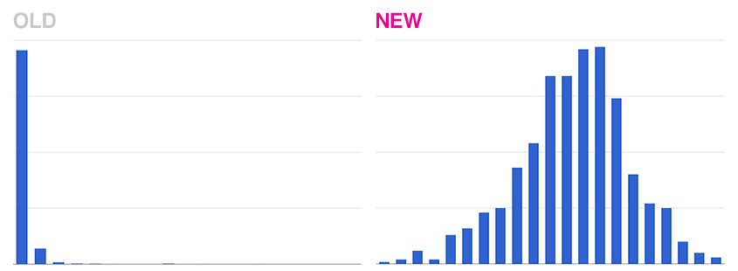

## Engineering + Finalization

**Rules**

**Tasks**

**User experience**

## Market research

### Pricing

Quirky uses a pricing game to help determine the appropriate price for new products. The community members are shown a summary of the new product with a picture, and then asked to give their price estimates using four different framings: too cheap, good bargain, bit pricey, and too expensive. The answers are aggregated over all users and the aggregated results are shown as feedback, with the user’s own estimates indicated in the graphs.

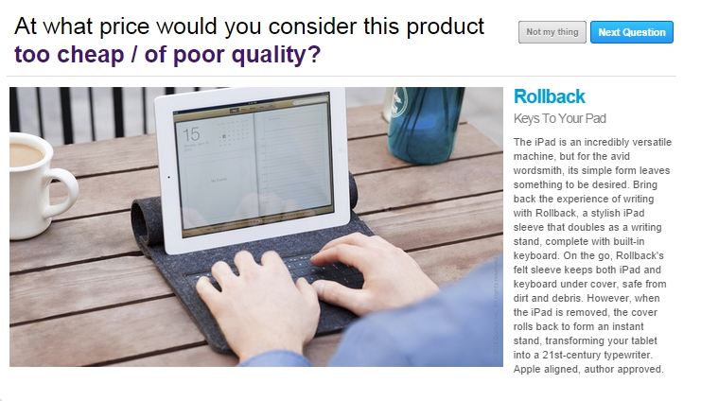

**Rules**

1. Share your pricing insights within first 7 days of product entering *Upcoming phase* and you will earn influence

**Tasks**

The pricing game has four questions for each product, after which the results are displayed:

1. Description of product
2. At what price would you consider this too expensive / not worth the money?
3. At what price would you consider this too cheap / of poor quality?
4. At what price would you consider this a good value / bargain?
5. At what price would you consider this a bit pricey but still worth buying?
6. Feedback: Current projected price for Kitchengami is $14.00. Then comparison of aggregate prices with bar chart and my choices

**User experience**

Playing pricing game. This feels smart. It even gives cognitive punishments to people who don’t give a price by asking more specific questions. Pricing game is kind of fun, perhaps even my second favorite task on Quirky after the Naming game. It is difficult to know the appropriate price. At feedback I feel like getting the price right or wrong depending on how close by guess is to the aggregate value. I’m even trying to adjust my guesses to get closer to the average. After adjusting for differences in currencies (€ vs $) my price estimates are regularly within $1 of the “correct” value. Pricing game is somehow tempting: after pricing the only way to move forward is to go to the next price evaluation task. Smart move, Quirky…

While checking what the pod power is, I did the pricing task. Just to make it go away.

### Pre-order

Apparently at Quirky the products go to market only if they gain enough preorders. I don’t have experience on this aspect of the process.

**Rules**

1. If a product gets enough preorders a factory in China starts production. Products have a presale threshold
2. Product ideas must retail for less than $150, no integrated software
3. Quirky staff works out production details

**Tasks**

**User experience**

## Green light

**Rules**

**Tasks**

**User experience**

### Manufacturing

**Rules**

**Tasks**

**User experience**

## Social sales, direct sales, Retail + international sales

**Rules**

**Tasks**

**User experience**

## Cash in

**Rules**

**Tasks**

**User experience**